2014-CZ-02a-EN Laterality
0 ---- | I: ---- | II: hard | III: easy | IV: easy

Answer Type: Multiple Choice Graphics are: self made and colorblind proof

Body

Psychologists made a test of laterality in the classroom consisting of three tasks and answers were stored in a computer. The tasks were:
1. Clasp hands: they recorded whether left or right thumb was above.
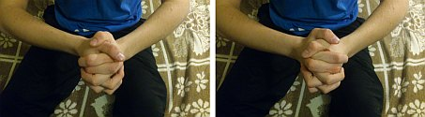
2. Look at the picture and immediately tell, which animal do you see: they recorded whether student saw a head of rabbit or duck.
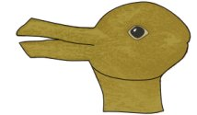
3. Give a clap: they recorded whether left or right hand was above.
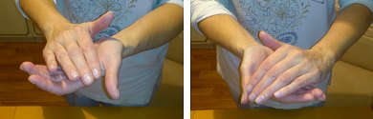
The psychologists have to come up with a different code for each possible outcome of the three task test.

Question

How many different codes should there be at least?

Answer

A) 1
B) 3
C) 8
D) 16

Explanation

Every tasks allows 2 possible answers (left – right thumb, rabbit – duck, left – right hand) and since the tasks are independent, this requires 2*2*2= 8 codes, which is the correct answer.

The original task was asking about the number of bits to record the result of individual testing. However, due to preknowledge factor about a notion of a bit, the task was changed. The original version still exists as 2014-CZ-02a.

It's informatics

Encoding of information is one of the basic problems in informatics. Moreover, the codes have to be designed in a such a way that they are from a rich enough domain that one can distinguish between different information.

Keywords

Information units, digital literacy

Websites

Internal Use

Wording

Some information on the label – numbers, measurement units, codes, addresses on the photo of a part of the label

Comments

Original task was on the number of bits needed to record the outcome of the test. To avoid the issue of pre-knowledge requirement on a notion of a bit, the task was changed to ask about the number of different outcomes.

Files

All additional files for this task (graphics, scripts, etc.)
2014-CZ-02a-EN Laterality.odt (this file)
2014-CZ-02a-laterality1ab - 3ab.jpg (original photos of pictures of hands – both variants)
2014-CZ-02a-laterality2.svg (graphics of the animal)

Authorship

Jiří Vaníček, vanicek@pf.jcu.cz, Czechia

License

Copyright © Bebras – International Contest on Informatics and Computer Fluency.
This work is licensed under a Creative Commons Attribution-ShareAlike 3.0 Unported License. Visit: http://creativecommons.org/licenses/by-sa/3.0/

